**PART-A**

**7. Create the following drawing using SVG.**

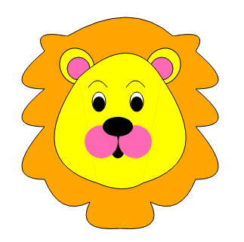

**HTML CODE:**

<!DOCTYPE html>

<html>

<head>

<title>SVG Lion</title>

</head>

<body>

<svg height="800" width="960" xmlns="http://www.w3.org/2000/svg">

<path d="M 150 80 Q 235 30 290 80" stroke="black" fill="orange" />

<g id="fur">

<path d="M 120 100 Q 100 70 150 80" stroke="black" fill="orange"/>

<path d="M 120 100 Q 60 150 120 150" stroke="black" fill="orange" />

<path d="M 120 150 Q 60 200 120 200" stroke="black" fill="orange" />

<path d="M 120 200

Q 60 270 120 270

Q 140 320 180 300

Q 160 340 220 335

" stroke="black" fill="orange" />

</g>

<use xlink:href="#fur" transform="translate(440,0) scale(-1,1)" />

<rect x="120" y="80" width="200" height="150" fill="orange"></rect>

<polygon points="130,230 220,335 300,230" fill="orange" />

<g id="ear">

<ellipse cx="163" cy="120" rx="22" ry="25" stroke="black" fill="yellow" transform="rotate(-35,163,120)" />

<circle cx="165" cy="123" r="15" stroke="black" fill="hotpink" />

</g>

<use xlink:href="#ear" transform="translate(440,0) scale(-1,1)" />

<g id="face">

<path d="M 165 135 Q 90 245 190 275" stroke="black" fill="yellow" />

</g>

<use xlink:href="#face" transform="translate(440,0) scale(-1,1)" />

<polygon points="165,135 275, 135 250,275 190,275" fill="yellow" />

<path d="M 165 135 Q 235 70 275 135" stroke="black" fill="yellow" />

<path d="M 190 275 Q 225 290 250 275" stroke="black" fill="yellow" />

<g id="eye">

<path d="M 178 148 Q 190 130 203 148" stroke="black" fill="transparent" />

<ellipse cx="192" cy="167" rx="9" ry="13" stroke="black" fill="white" />

<ellipse cx="192" cy="170" rx="8" ry="10" />

</g>

<use xlink:href="#eye" transform="translate(50,0)" />

<ellipse cx="217" cy="227" rx="10" ry="15" fill="black" />

<circle cx="195" cy="220" r="22" fill="hotpink" />

<circle cx="240" cy="220" r="22" fill="hotpink" />

<ellipse cx="217" cy="200" rx="20" ry="13" fill="black" />

</svg>

</body>

</html>

**OUTPUT:**



**PART-B**

**4. Create a web page using HTML/CSS which contains cards (shown as a stack of cards) with image of a tourist place and below that is a thumbnail (shown in circle with image), when mouse hovers over thumbnail corresponding card comes in front and also small description about the tourist place will be displayed. All these must happen using css animation and transition.**

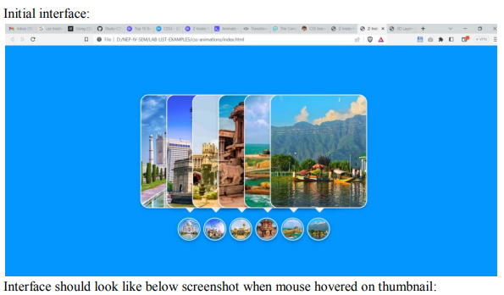

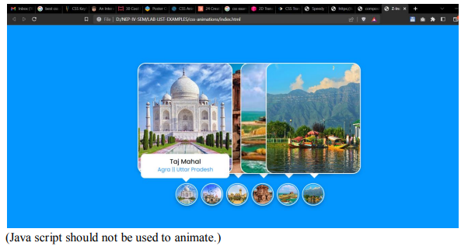

**HTML CODE:**

<!DOCTYPE html>

<head>

<title> Hover Animation </title>

<link rel="stylesheet" href="style.css">

</head>

<body>

<div class="container">

<div class="icon-image">

<div class="icon">

<img src="agra.jpg" alt="">

</div>

<div class="hover-image">

<div class="img">

<img src="agra.jpg" alt="">

</div>

<div class="content">

<div class="details">

<div class="name">Taj Mahal</div>

<div class="job"> Agra || Uttar Pradesh</div>

</div>

</div>

</div>

</div>

<div class="icon-image">

<div class="icon">

<img src="hampi.jpg" alt="">

</div>

<div class="hover-image">

<div class="img">

<img src="hampi.jpg" alt="">

</div>

<div class="content">

<div class="details">

<div class="name">Hampi</div>

<div class="job">Ballari || Karnataka</div>

</div>

</div>

</div>

</div>

<div class="icon-image">

<div class="icon">

<img src="dallake.jpg" alt="">

</div>

<div class="hover-image">

<div class="img">

<img src="dallake.jpg" alt="">

</div>

<div class="content">

<div class="details">

<div class="name">Daal Lake</div>

<div class="job">Kashmir || Kashmir</div>

</div>

</div>

</div>

</div>

</div>

</body>

</html>

**CSS CODE:**

*{

box-sizing: border-box;

font-family: 'Poppins',sans-serif;

}

body{

height: 100vh;

width: 100%;

display: flex;

justify-content: center;

align-items: center;

background: #0396FF;

}

.container{

height: 500px;

display: flex; //block

min-width: 400px;

align-items: flex-end;

}

.icon-image{

position: relative;

height: 70px;

width: 70px;

cursor: pointer;

border-radius: 50%;

background: #fff;

}

.icon-image .icon img{

position: absolute;

height: 95%;

width: 95%;

left: 50%;

top: 50%;

transform: translate(-50%, -50%);

object-fit: cover;

border-radius: 50%;

border: 3px solid #0396FF;

}

.icon-image .hover-image{

position: absolute;

height: 350px;

width: 300px;

bottom: 100px;

left: 50%;

transform: translateX(-50%);

}

.icon-image:hover .hover-image{

left: -200px;

z-index: 12;

transform: translateX(80px);

transition: left 0.5s ease, z-index 0s, transform 0.5s ease;

transition-delay: 0s, 0.5s, 0.5s;

}

.hover-image img{

position: absolute;

height: 100%;

width: 100%;

object-fit: cover;

border: 3px solid #fff;

border-radius: 25px;

}

.hover-image .content{

position: absolute;

width: 100%;

bottom: -10px;

padding: 0 10px;

}

.content::before{

content: '';

position: absolute;

height: 20px;

width: 20px;

background: #fff;

left: 50%;

bottom: -7px;

transform: rotate(45deg) translateX(-50%);

z-index: -1;

}

.content .details{

position: relative;

background: #fff;

padding: 10px;

border-radius: 12px;

text-align: center;

opacity: 0;

}

.icon-image:hover .details{

transition: all 0.5s ease;

transition-delay: 0.9s;

opacity: 1;

}

.content .details .name{

font-size: 20px;

font-weight: 500;

}

.content .details .job{

font-size: 17px;

color: #0396FF;

}

**5. Create a web page using HTML5/CSS3 to animate a truck movement. While truck moves trees should move in the back ground. Output screen shot:**

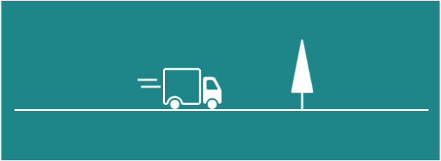

For tree, truck and wheels download the images from the following URLs.

<https://s3-us-west-2.amazonaws.com/s.cdpn.io/130015/tree.svg>

<https://s3-us-west-2.amazonaws.com/s.cdpn.io/130015/truck.svg>

<https://s3-us-west-2.amazonaws.com/s.cdpn.io/130015/wheels.svg>

Animation must be pure CSS and Java script should not be used.

**HTML CODE:**

<!DOCTYPE html>

<head>

<title>Speedy Truck</title>

<link rel="stylesheet" href="speedytruck.css">

</head>

<body>

<div class="loop-wrapper">

<div class="mountain"></div>

<div class="hill"></div>

<div class="tree"></div>

<div class="truck"></div>

<div class="wheels"></div>

</div>

</body>

</html>

**CSS CODE:**

body {

background: #009688;

}

.loop-wrapper {

margin: 0 auto;

position: relative;

width: 600px;

height: 250px;

overflow: hidden;

border-bottom: 3px solid #fff;

}

.tree{

position: absolute;

height: 100px;

width: 35px;

bottom: 0;

background: url(tree.svg) no-repeat;

}

.truck, .wheels {

width: 85px;

bottom: 0px;

right: 50%;

position: absolute;

}

.truck {

background: url(truck.svg) no-repeat;

height: 60px;

}

.truck:before {

content: " ";

position: absolute;

width: 25px;

box-shadow:

-30px 28px 0 1.5px #fff,

-35px 18px 0 1.5px #fff;

}

.wheels {

background: url(wheels.svg) no-repeat;

height: 15px;

}

.tree { animation: tree 3s 0.000s linear infinite; }

@keyframes tree {

0% { transform: translate(1350px); }

50% {}

100% { transform: translate(-50px); }

}

**OUTPUT:**



**8. Create a web page which must be as shown in below image using HTML5, SVG and CSS3. Here Mountain must be drawn using SVG, Stars in sky changes their position randomly for every time page is loaded (java script can be used). Sky and stars must be created using element.**

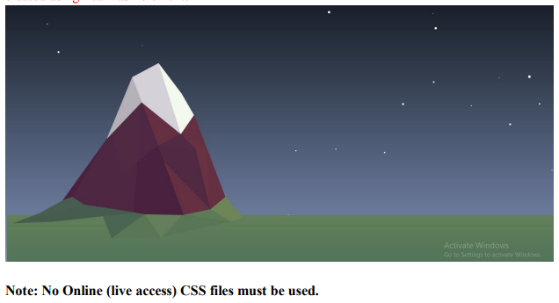

**HTML CODE:**

<!DOCTYPE html>

<head>

<title> SVG SCENE</title>

<link rel="stylesheet" type="text/css" href="sky.css"/>

<script>

window.onload = function()

{

var sky = document.getElementById("sky");

sky.width = document.body.clientWidth;

sky.height = document.body.clientHeight;

if (sky.getContext){

var skyContext = sky.getContext("2d");

var radius = 2;

for(var star = 0; star < 50; star++){

var min = ( Math.random() * 30 + 5 ) / 10;

var max = sky.width - radius;

var centerX = Math.floor(Math.random() * (max - min + 1)) + min;

var centerY = Math.floor(Math.random() * (max - min + 1)) + min;

skyContext.beginPath();

skyContext.arc(centerX, centerY, min, 0, 2 * Math.PI);

skyContext.fillStyle = "rgb(255, 255, 255)";

skyContext.fill();

}

}

}

</script>

</head>

<body>

<section class="stage">

<svg height="390" width="550" id="mountains">

<polygon points="300,390 190,90 320,130 400,340" fill="#5d2042" />

<polygon points="0,340 108,190 194,100 201,120 301,390" fill="#320e40" />

<polygon points="14,348 117,174 194,102 172,377" fill="#3b1642" fill-opacity="0.8" />

<polygon points="120,174 194,102 233,206 144,275" fill="#3d1744" fill-opacity="0.9" />

<polygon points="233,206 288,177 324,214" fill="#421943" />

<polygon points="233,206 324,214 247,245" fill="#3e1743" />

<polygon points="247,245 324,214 360,360" fill="#411842" />

<polygon points="324,214 288,177 350,210" fill="#632242" />

<polygon points="324,214 350,210 360,360" fill="#652343" />

<g id="apex">

<polygon points="108,190 170,40 194,100" fill="#aeacb9" />

<polygon points="170,40 234,6 260,70 288,178 194,102" fill="#ceced8" />

<polygon points="234,6 290,80 320,132 288,178" fill="#ffffed" />

</g>

</svg>

<svg id="ground"></svg>

<svg id="hills" width="700" height="170">

<polygon points="480,70 530,100 560,90 516,40" fill="#9b9d57" />

<polygon points="480,70 530,100 412,84" fill="#7d8f57" />

<polygon points="530,100 412,84 360,138" fill="#748857" />

<polygon points="360,138 240,140 320,82" fill="#748857" />

<polygon points="412,84 360,140 320,82" fill="#88945a" />

<polygon points="320,82 240,140 210,64" fill="#597252" />

<polygon points="300,78 100,100 0,104 170,58" fill="#4f654f" />

<polygon points="172,58 145,40 122,48 66,79 0,104" fill="#536a50" />

</svg>

<canvas id="sky"></canvas>

</section>

</body>

</html>

**CSS CODE:**

html, body {

height: 100%;

width: 100%

}

body {

min-height: 100%;

background: linear-gradient(to bottom, #0a1a27, #4e83b7);

position: relative;

}

body #mountains {

z-index: 2;

position: absolute;

bottom: 20%;

margin-bottom: -16px;

left: 10%;

}

body #ground {

z-index: 1;

width: 100%;

height: 20%;

position: absolute;

bottom: 0;

background: #879759;

background: linear-gradient(to bottom, #879759, #648459);

}

body #hills {

//background: rgba(255, 0, 0, 0.3);

position: absolute;

left: 10%;

margin-left: -120px;

margin-bottom: -86px;

bottom: 20%;

z-index: 3;

}

body #stars {

width: 100%;

height: 100%;

}

**OUTPUT:**

